Data Activity 7
Cross-Tabulation Analysis – COVID-19 India Dataset
Method
The COVID-19 India dataset was imported into R and explored to identify the relevant variables. Total confirmed cases were calculated by combining ConfirmedIndianNational and ConfirmedForeignNational. Cases were then grouped into three severity categories: Low (0–10), Medium (11–50) and High (>50). States and Union Territories were grouped into geographical regions to allow comparison.
For the recovery analysis, the Cured variable was grouped into No Recovery (0), Low Recovery (1–10) and Higher Recovery (>10). Cross-tabulation was then used to explore the relationship between region and case severity, followed by the relationship between case severity and recovery status.
Evidence 1 – Creating the Variables
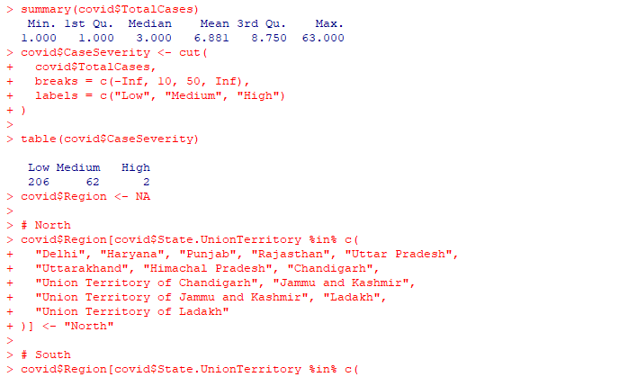

Figure 1. Creation of total confirmed cases and case severity categories in R.
Evidence 2 – Region × Case Severity
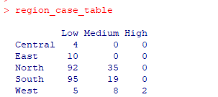
Figure 2. Cross-tabulation of geographical region and COVID-19 case severity.
Findings: The cross-tabulation showed that most observations were classified as low severity. The South recorded the highest number of low-severity observations (95), closely followed by the North (92). Medium-severity observations were most frequent in the North (35), while the West was the only region to contain high-severity observations (2). This demonstrates differences in the distribution of recorded case levels between geographical regions during the period examined.

Evidence 3 – Case Severity × Recovery Status
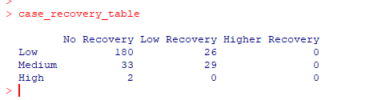
Figure 3. Cross-tabulation of case severity level and recovery status.
Findings: Most low-severity observations were associated with no recorded recoveries (180), while 26 had low recovery. Medium-severity observations were more evenly distributed, with 33 showing no recovery and 29 showing low recovery. Both high-severity observations had no recorded recoveries, and no observations were classified as higher recovery.
Reflection
This exercise helped me understand how continuous numerical data can be converted into meaningful categorical variables and examined using cross-tabulation. I also learned that the way categories are defined can influence the patterns observed. The analysis should therefore be interpreted cautiously, as the dataset contains state-level observations recorded over time rather than individual patient outcomes. Cross-tabulation identifies associations and patterns within the data but does not establish causation.
